**Project Design Phase**

**Problem – Solution Fit Template**

|  |  |
| --- | --- |
| Date | 27 June 2025 |
| Team ID | LTVIP2025TMID31894 |
| Project Name | Health AI: Intelligent Healthcare Assistant Using IBM Granite |
| Maximum Marks | 2 Marks |

##### Problem-Solution Fit

There is a rising demand for accessible, AI-based health assistants that do not require login, are easy to use, and provide instant answers.

**Purpose of Problem–Solution Fit**

The goal is to confirm that HealthAI genuinely addresses a real user problem and that the solution design fits naturally within user behavior, needs, and environment. This alignment increases the probability of adoption and success.

**Proposed Solution**

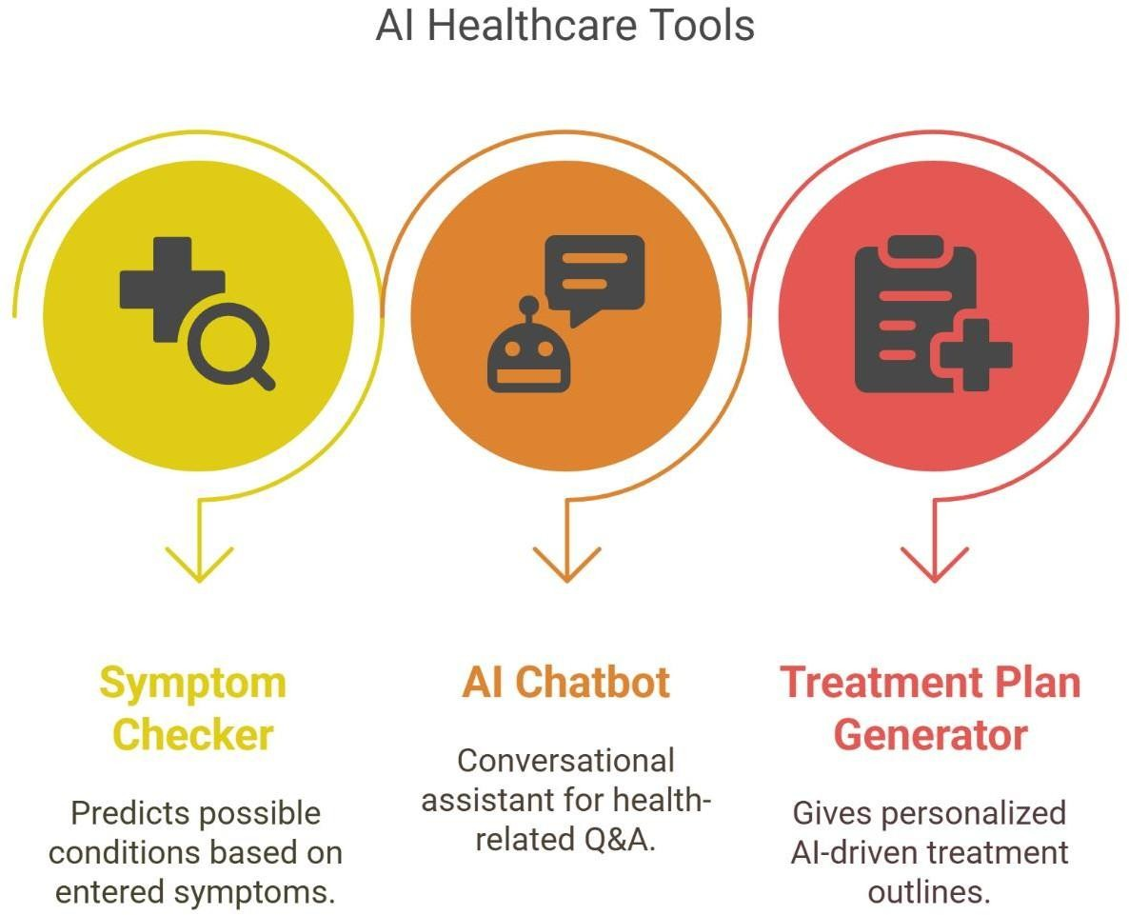

**Solution Architecture**

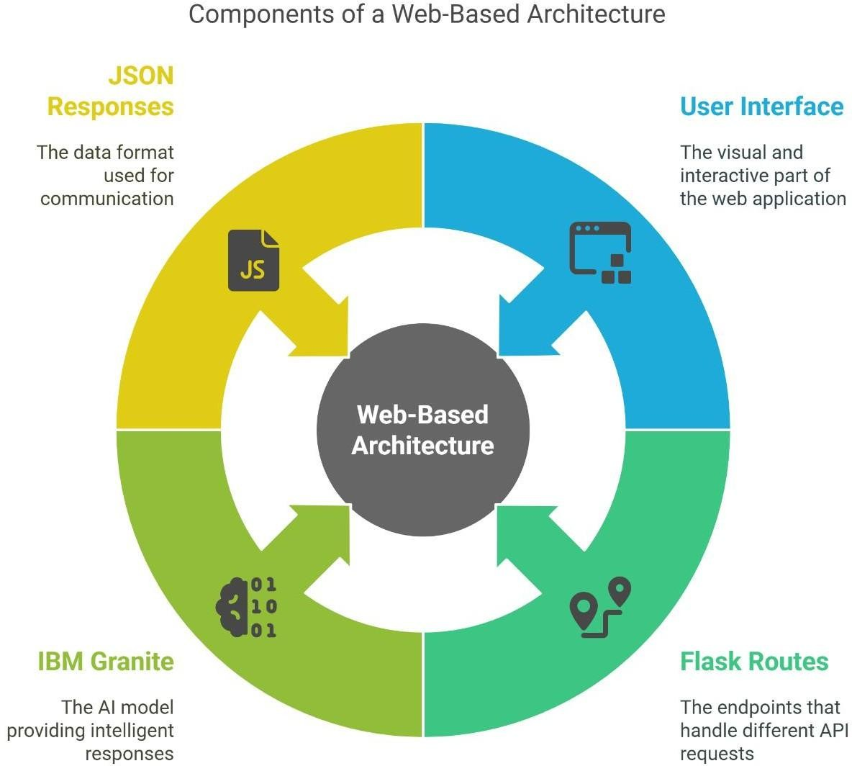

A web-based architecture:

* User Interface (HTML/CSS/JS)
* Flask routes (/api/chat, /api/predict, /api/treatment)
* IBM Granite for intelligent responses
* JSON responses and dynamic UI updates